*****ADD*****

BookingChangesTable

**BookingChanges Table**

Order types:

1. From lounge ---> subset table
2. From online ---> subset table
3. Takeaway ---> same table no added fields
4. Using rooms lounge or online

IOT system to lock rooms in reservation time

Add automation system to specify orders to deliveries based on availability and location

Add automation to send orders to best branch based on address and stock availability

Field Specifications for Each Field in the Database

Add change recipes table

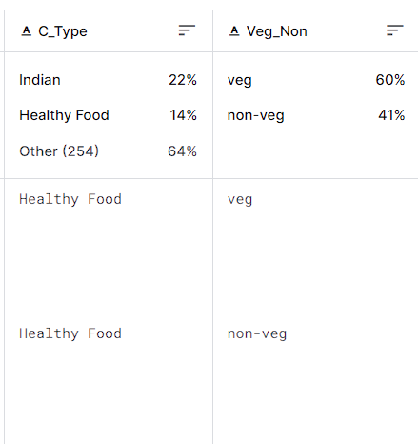

Add items type

Add item_discount_changes

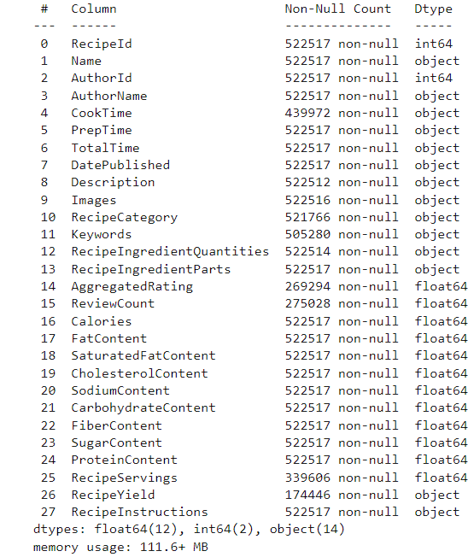

Add periodEmployee table

Add item_discount data type 5 10 15 20 25 30 35 100

Create json view for menu items

Normalization

Redesign order tables to apply virtual room orders p273

**Add Business Rule Specifications Sheets**

****** complete other tables fields